Homework 1 - Due by 11:00pm pm Monday March 6:

All homework are to be submitted as attached file(s) via email. Consider organizing you results into respective subfolders within your “Homework_1” folder. When you are done, compress the “Homework_1” folder into a zip file “LASTNAME_hw1.zip” and submit the compressed file via email to leizhou@ufl.edu.

An office hour for homework_1 will be held on March 6th after the class (1-2pm) in CGRC-291.

I.) Web-based bioinformatics resources (20 points):

Identify at least 2 web services that provide RNA structure prediction.

Try out a sample query (any RNA of interest to you) using the two services. Compare the outcome (i.e. Is there any difference? and if so, why?). Turn in the output and your analysis as .pdf file(s).

II.) Functional databases (20 points):
Retrieve the pathway and functional information related to the gene of your interest from the following databases: NCBI/Gene, EBI/UniProt, KEGG, Reactome, and another one of your choice. Save the search results as either .html/htm or .pdf file.

III.) Log into HiPerGator, navigate to the /blue/gms6014/share/ folder. Make a subfolder with your first name, cd into your subfolder and then follow the practice introduced in the HiPerGator command line tutorial. Submit the “lengths.txt” file or the screen lift image similar as below (30 points).

Example from the tutorial:

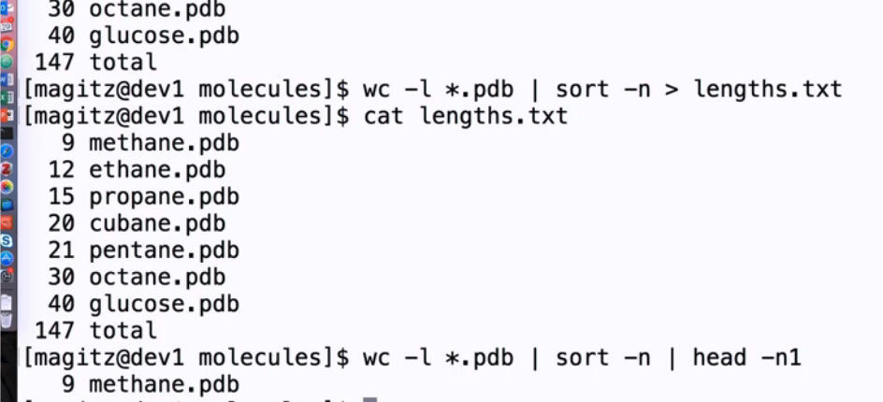
IV.) Run command line BLAST in your own computer. Alternatively you may do so in HiPerGator (30 pts).
For your search, download a Non-mammalian genome (predicated cDNAs) from Ensemble FTP ; Search (BLASTP or TBLASTN) the genome with a query sequence of interest to you. Change the E value so there are between 1-20 hits on your report. Submit the BLAST output as a .html file.
V.) (Optional, for extra credits) Download and install Python (http://www.python.org/), Biopython (http://www.biopython.org/). Try an example program from the Tutorial book. Submit the code as well as result. (20 pts)

